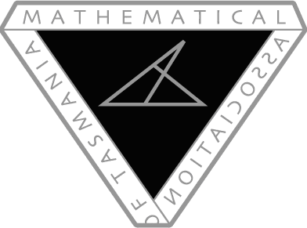

MAT Conference 2017

Remote Area Bursary Application

In 2017, the Mathematical Association of Tasmania is offering ten bursaries for teachers living and working in remote areas of Tasmania. These bursaries comprise of FREE registration to either the MAT Conference 2017 (excluding dinner) OR the Early Career Mathematics Teachers Day (choose one) AND $100 towards transport/accommodation.

I am applying for free registration for (specify MAT Conference OR Early Career Maths Teachers Day):

Name of Applicant:

School:

Position:

Residential Address:

Contact Email:

Contact Phone:

Why do you think that participating in the MAT Conference 2017 / Early Career Maths Teachers Day will be a valuable experience for you?

The information given on this form, particularly your answer to the question, will be used to rank applications if more than ten applications are received.

Please return completed forms to Brett Stephenson: bstephenson@gyc.tas.edu.au. Forms completed in hard copy should be scanned/photographed and emailed as an attachment. Bursaries are due by April 20th 2017 (to give you time to make travel plans after you have been notified about the progress of your application).

